WSLHA Annual Convention

Pathways from Research to Intervention
October 12 - 14, 2017 | Seattle Marriott Bellevue | Bellevue, WA
Thank you for joining us!

Convention Program & Schedule
Convention Schedule
Abstracts, Objectives, and Bios

Continuing Education Information
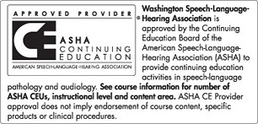
This course is offered for up to 1.55 ASHA CEUs (Various level, Professional area).
- State Clock Hours up to 15.5 CECHs and ASHA CEUs are processed free for WSLHA members.
- Non-members will pay a processing fee at the convention. CECHs $10.00 / CEUs $15.00.
WSLHA charges a processing fee. Please bring checks payable to WSLHA. Please bring your ASHA number.
Payment of an annual ASHA CE Registry fee is required in order for you to earn ASHA CEUs. CE Registry fees are paid by the participant directly to ASHA. The annual CE Registry fee allows you to earn an unlimited number of ASHA CEUs for the calendar year. The 2017 fee is $25 for ASHA/NSSLHA members and $35 for nonmembers; the 2018 fee is $28 for ASHA/NSSLHA members and $38 for nonmembers. Contact ASHA (800-498-2071) to pay your CE Registry fee.

Pricing
 | Member | Non-Member
Full Convention | SLP Member - $295.00  SLPA/Para-Professional Member- $220.00  *Student Member - $100.00 | SLP Non-Member - $405.00  SLPA/Para-Professional Non-Member - $245.00  *Student Non-Member - $120.00
One Day Only | SLP Member - $195.00  SLPA/Para-Professional Member - $140.00  *Student Member - $70.00 | SLP Non-Member - $265.00  SLPA/Para-Professional Non-Member - $150.00  *Student Non-Member - $90.00
Members of MSHA, ISHA, OSHA, BCSHA, WOTA and PTWA can register at member rates by contacting the WSLHA office.
*Students interested in volunteering at the convention should contact Nancy Alarcon before registering.

Hotel/Venue Information
Seattle Marriott Bellevue
200 110th Avenue NE
Bellevue, WA 98004
Make your room reservation online.
Parking:
- Marriott: valet parking (including in and out privileges) = $25/day
- Map of nearby garages/lots (price varies)

Sponsors & Exhibitors
2017 Convention Exhibitor and Sponsorship Prospectus

Drawing Prize Donations
Please consider donating items for the drawing prize! The funds from this drawing go to support WSLHA's student scholarship fund. In the past we've received therapy materials, gift certificates, jewelry, art, crafts, and hobby items. If you have something to donate, please contact us!

Thank You to Our Sponsors and Exhibitors!

 | 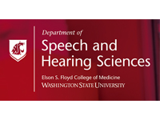 | Tobii Dynavox
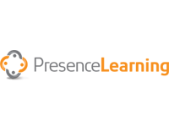 | 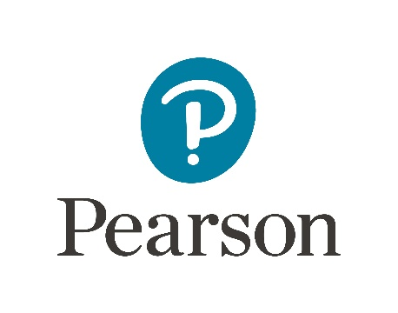 | 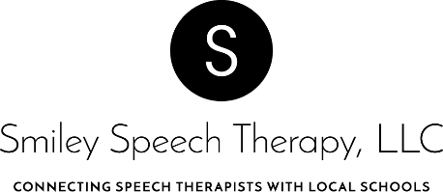
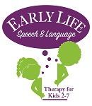 |  | 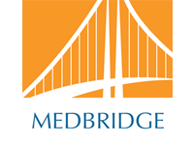
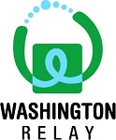 | University of Washington  Autism Center  University of Washington  Speech and Hearing  Sciences Advisory Council | Northwest ABA
 | Ensign Services
 | Northwest Access Fund | Auburn School District

