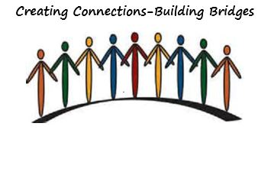
WSLHA Annual Convention
Creating Connections - Building Bridges
October 13 - 15, 2016 | Hotel Murano Conference Center, Tacoma, WA

Thank you for attending the 2016 Convention!
Member Pricing
Full Convention
SLP Member - $295.00
SLPA/Para-Professional Member- $220.00
*Student Member - $65.00
One Day Only:
SLP Member - $195.00
SLPA/Para-Professional Member - $140.00
*Student Member - $35.00
Non-Member Pricing
Full Convention:
SLP Non-Member - $405.00
SLPA/Para-Professional Non-Member - $245.00
Student Non-Member - $90.00
One Day Only:
SLP Non-Member - $265.00
SLPA/Para-Professional Non-Member - $150.00
Student Non-Member - $45.00
Members of MSHA, ISHA, OSHA, BCSHA, WOTA and PTWA can register at member rates by contacting the WSLHA office.
*Students interested in volunteering at the convention should contact Nancy Alarcon before registering.
Register by August 19th and receive a 10% discount on registration fees!
Continuing Education Information
This course is offered for up to 1.55ASHA CEUs (Various levels, Professional area)
State Clock Hours up to 15.5 CECHs and ASHA CEUs are processed free for WSLHA members.
Non members will pay a processing fee at the convention. CECHs $10.00 / CEUs $15.00.
Please bring checks payable to WSLHA. Please bring your ASHA number.
Pre-registration is closed. Walk-ins are welcome.

Venue
Hotel Murano
1320 Broadway Plaza
Tacoma, WA 98042
253-238-8000
info@hotelmuranotacoma.com

Convention Program & Schedule
Convention Schedule
Abstracts, Objectives, and Bios
Planners and Presenters Disclosures

Sponsors & Exhibitors
2016 Convention Exhibitor Information

Thank You to our Sponsors
