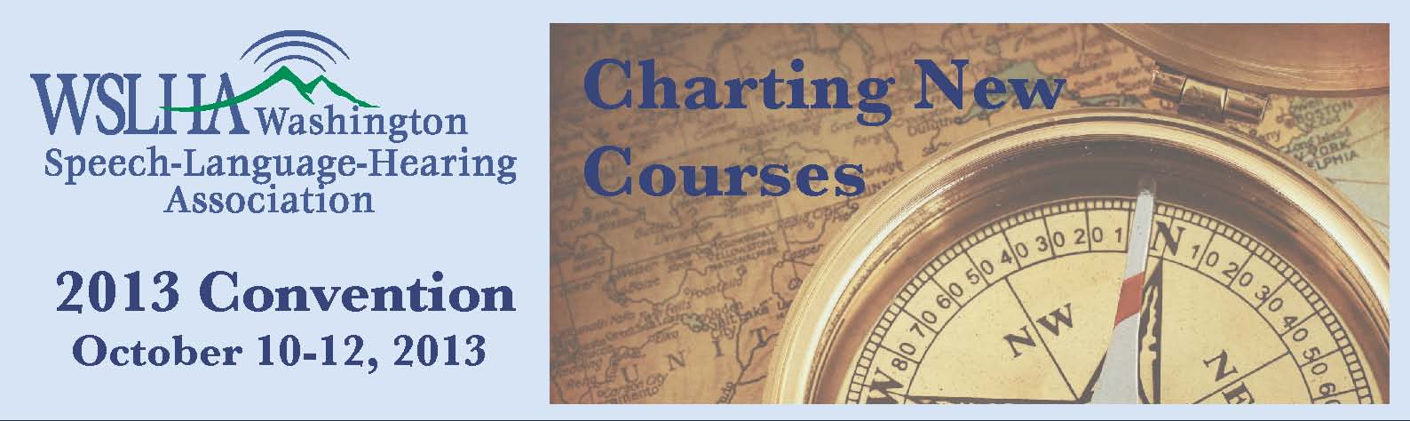

2013 WSLHA Convention: Charting New Courses
Everett Holiday Inn Event Center
3105 Pine Street | Everett, WA 98201
Program Schedule
Speaker Disclosures
2013 Sponsors & Exhibitors
Premiere Sponsor:
EBS Healthcare
Convention Sponsor:
Pentax Medical
Exhibitors:
CaptionCall
Cookie Lee Jewelry Fundraiser for Stuttering Foundation
Dependable Medical Equipment
JOTx
Piel Canela Peru Fair Trade Organization
Smarty Ears
Supplemental Health Care
Therapists Unlimited
TinyEYE Therapy Services
WA Relay

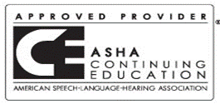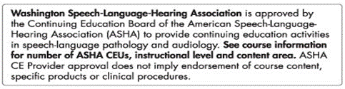
This course is offered for up to 1.6 ASHA CEUs and 16 CECH
(Various levels, Professional area)
State Clock Hours CECHs and ASHA CEUs are free for WSLHA members. Non members will pay a processing fee at the convention. CECHs $10.00 CEUs $15.00. Please bring checks payable to WSLHA. Please bring your ASHA number.

