January 14, 2022

Janet Woodcock, MD
Acting Commissioner
Food and Drug Administration
5630 Fishers Lane, Rm 1061
Rockville, MD 20852

RE: Docket No. FDA-2021-M-0555, RIN 0910-AI21, Medical Devices; Ear Nose, and Throat Devices; Establishing Over-the-Counter Hearing Aids

Comments submitted electronically via www.regulations.gov

Dear Commissioner Woodcock:

On behalf of the Washington State Academy of Audiology (WSAA) and the Washington Speech-Language-Hearing Association (WSLHA), we are providing comments on the proposed rule, Medical Devices; Ear, Nose and Throat Devices; Establishing Over-the-Counter Hearing Aids. Our organizations represent audiologists and speech-language pathologists in Washington state. While we recognize the Food & Drug Administration’s (FDA) work on rule-making to implement the law regarding over-the-counter (OTC) hearing aids as established by the FDA Reauthorization Act of 2017 (FDARA), we have concerns that these rules will not adequately protect the consumer and could lead to patient harm and further hearing loss.

We know that hearing impairments are not one size fits all, therefore our solutions can’t be either. OTC hearing aids would require consumers to self-diagnose their level of hearing loss and would face undue risk in using these products if left under-regulated. Consistent with consensus recommendations developed by professional hearing care associations, including the American Speech-Language-Hearing Association (ASHA) and the American Academy of Audiology (AAA), we ask for the following changes to the rule:

- Lower the proposed output to 110 dB SPL and establish a gain of 25 dB to protect a full-on gain limit of 25 dB
- Require input compression and volume control for all OTC hearing aids
- Define concise, outside‐of‐the‐box labeling appropriate for medical devices sold OTC, with strong recommendation to consult with a hearing health care professional
- Define the new OTC category so that it is easily comprehensible by consumers and in line with risk class requirements for safety and effectiveness
- Clarify the preemption of state laws and ensuring adequate provisions for consumer protection

Thank you for the opportunity to comment on these important rules.

Sincerely,
Bethany Davis, SLPD, CCC-SLP, CBIS
President, WSLHA

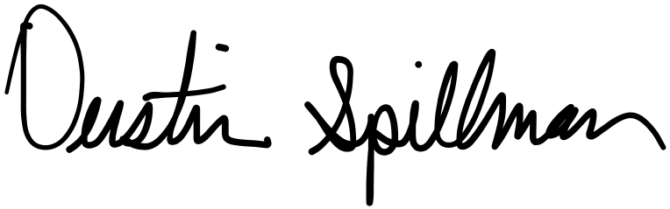

Dustin Spillman, Au.D.
President, WSAA

