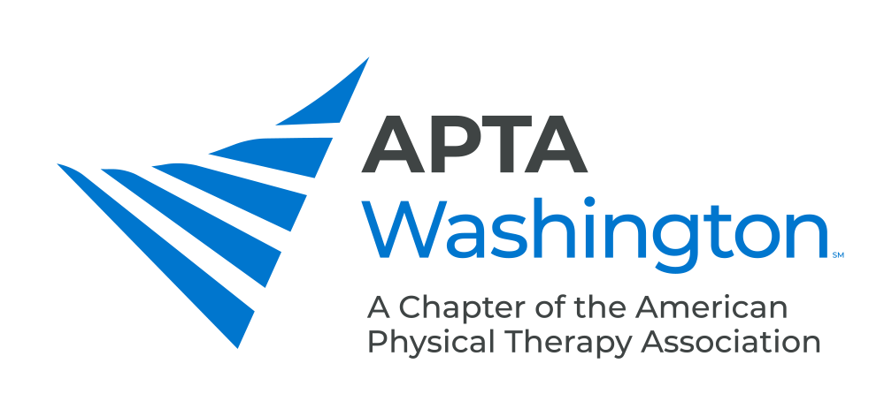

October 19, 2020

The Honorable Jay Inslee
Office of the Governor

Via Email

Dear Governor Inslee,

On behalf of the American Physical Therapy Association Washington (APTA-WA) the Washington Speech-Language-Hearing Association (WSLHA), and the Washington Occupational Therapy Association (WOTA) and their combined 4000 members, we are writing to urge you to reject the Health Care Authority’s budget proposal to eliminate the Medicaid Adult Rehabilitation benefit when drafting your budget for the 21-23 biennium. This proposal would impact the health of over 90,000 Washingtonians.

Rehabilitation includes physical therapy, occupational therapy, and speech therapy, all of which are crucial to a patient’s recovery from injury, surgery, stroke, and other conditions. Physical therapy and occupational therapy can reduce or eliminate acute and chronic pain from injuries, thus reducing the need for opioids to manage pain. Speech therapy treats communication disorders that cause problems with cognitive development, speech delays, listening, reading, and writing, and swallowing.

The elimination of the Adult Medicaid rehabilitation benefit doesn’t make sense from a human perspective, nor from a fiscal perspective. Without these important outpatient treatments, patients will not recover adequately from injuries, surgeries, stroke, and other conditions. They will not be able to return to school or work, will be in pain, potentially leading to opioid abuse. In short, they will lose their ability to function independently.

Through a fiscal lens, the state will lose important Medicaid matching dollars. More importantly, the state will pay more for these patients’ health care through unnecessary surgeries, hospital costs, and long term care stays.

We urge you to retain this important Medicaid benefit and reject the Health Care Authority’s budget proposal to eliminate the Medicaid Adult Rehabilitation benefit. Thank you for your careful consideration of our request.

Sincerely,
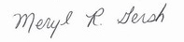
Meryl Gersh, PT, PhD
President, PTWA

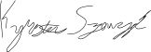
Kyrstin Szewczyk, OT
President, WOTA

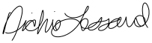
Nichie Lessard, SLP-CCC
President, WSLHA

