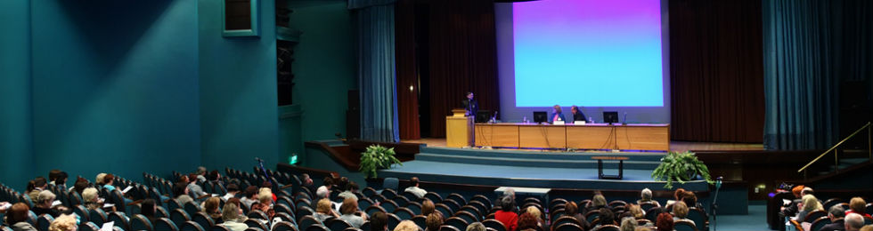
WSLHA Annual Convention
October 8 - 10, 2015 | Tacoma Convention & Trade Center
Thank you to all who attended the convention and helped to make this year's event a success! Mark your calendars for the 2016 WSLHA Convention, October 13-15 at Hotel Murano in Tacoma.

Access the Convention photos.

2015 Awards
Special Recognition Award: Albert Merati
Clinical Achievement Award: Sandra Bassett, Eva Baharav, and Amy Meredith.
Honors of the Association: Roberta Jackson
Venue
Greater Tacoma Convention & Trade Center
1500 Broadway
Tacoma, WA 98402
Tel: 253-830-6601
Email: contact@gtctc.org
Convention Program & Schedule
Convention Schedule
Abstracts, Objectives and Bios
Planners and Presenters Disclosures

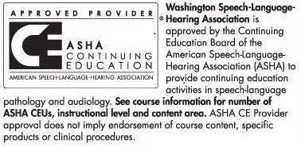
This course is offered for up to 1.7 ASHA CEUs (Various levels, Professional area)
State Clock Hours CECHs and ASHA CEUs are processed free for WSLHA members.
Non members will pay a processing fee at the convention. CECHs $10.00 CEUs $15.00.
Please bring checks payable to WSLHA. Please bring your ASHA number.
Convention Sponsors
